SALARY SURVEY-2021

Objectives :

The Salary Survey 2021 project analyzes salary trends across industries, job roles, and experience levels using Excel and SQL. It compares salary variations by country and city, identifies the highest and lowest earning regions, and examines gender pay differences. The project also evaluates the impact of experience and age on salaries. Using SQL for data analysis and Excel for visualization and dashboards, it provides insights to help professionals make informed career decisions and support fair compensation practices.

Dataset Description :

* Industry - The profession of the respondent.
* Job Title - The sector in which the respondent is employed.
* Educational Level – The highest educational level.
* Experience - The total years of experience in the field.
* Annual Salary – The Annual salary of the employees.
* Currency - The currency in which the salary is reported.
* Country - The country where the respondent is working.
* City - The specific city where the respondent is based.
* Age Group - The respondent’s age category
* Gender - The gender of the respondent.

Tools Used :

* Excel
* MySQL

Steps Involved :

1.Data Cleaning

* Removed duplicates
* Handled missing values
* Handled inconsistence values
* Replaced null values
* Handled inconsistence repeated values

2.Import Data into MySQL :

* Import the cleaned data in MySQL
* Create a Database
* Import data by using this query

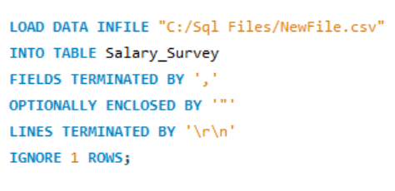

3.MySQL Queries

* Wrote query for filter data in particular criteria
* Totally ten queries involved in this procedure.
* Save that queries to export.

4.Export the Output

* Export each output of query
* Save these query outputs as CSV format.
* Add those files in a single Excel workbook by ten sheets for ten outputs.

5.Data Modelling

* Add these in Power pivot and add a data model
* Create relationships for each table
* Create pivot tables in this Power Pivot using those tables.

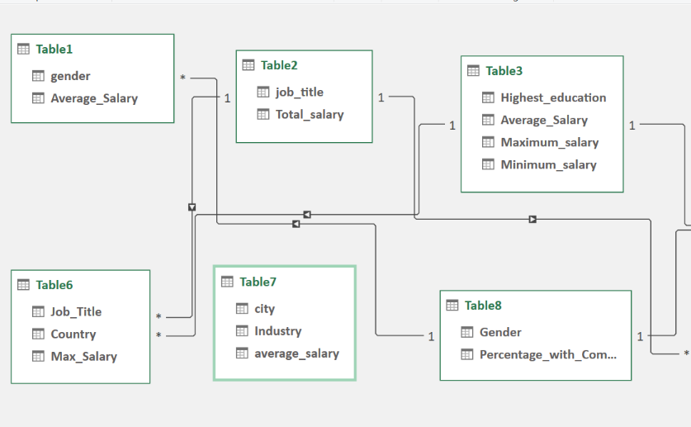

6.Dashboard Creation

* Create Pivot tables and in power pivot
* Create pivot charts and slicers for visualization
* Add Key Performance Indicators
* Align charts and slicers in Dashboard for visualization.

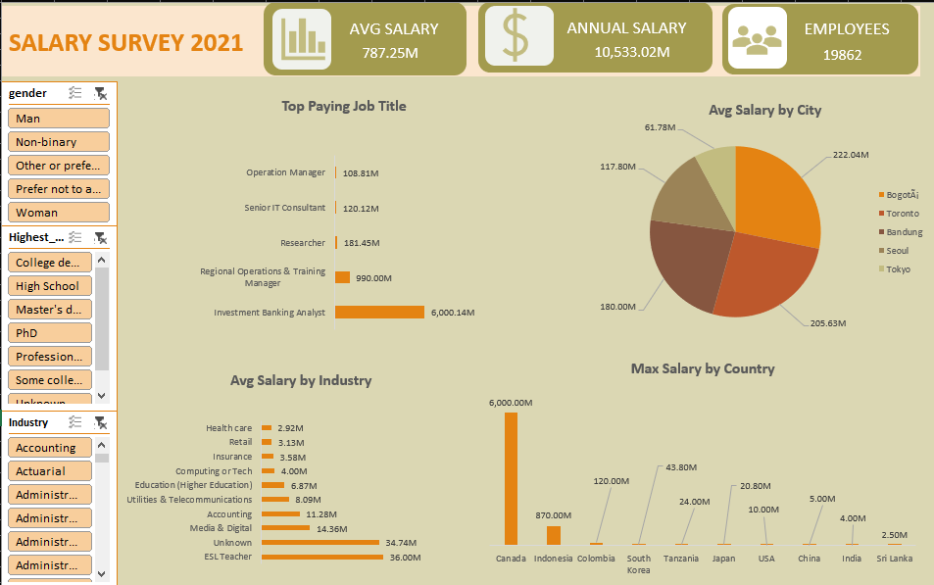

Insights :

* By this analysis we found that the High paying job is Investment Banking Analyst.
* The Maximum salary across all countries is Canada.
* The Maximum average salary by city is Bogota.
* The overall average salary is higher for women than men.
* The Highest Average salary by Age Range is Age greater than 65.
* Remote work opportunities may influence salary trends, offering cost-saving benefits for companies.

Conclusion :

The Salary Survey 2021 project analyzed salary trends using Excel and SQL, revealing key insights on high-paying jobs, country-wise salary variations, and gender-based differences.This analysis helps professionals make informed career decisions and supports fair compensation practices. Future improvements could include multi-year data analysis and additional salary factors for deeper insights.